curriculum vitae

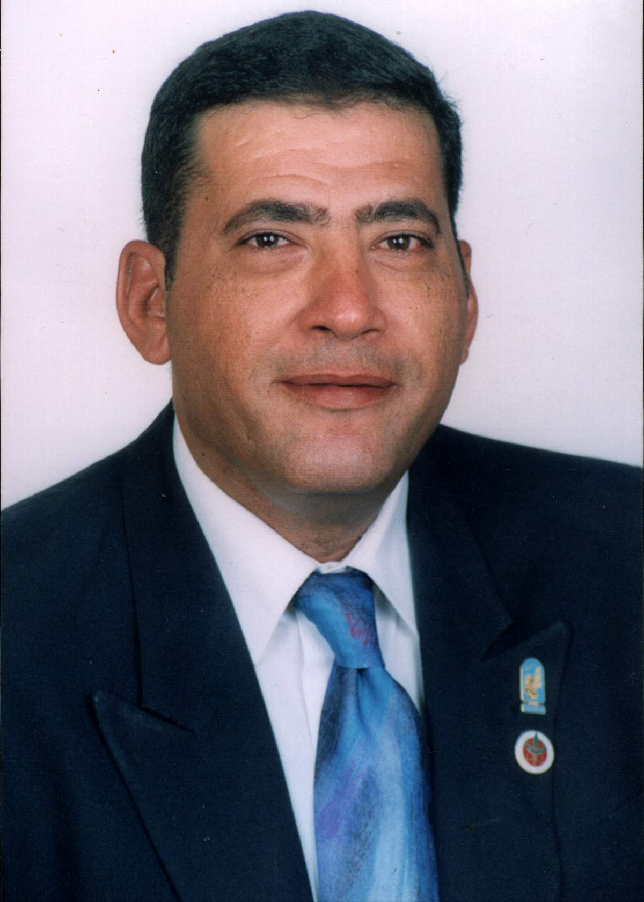
personal data
Name: Ahmed Yahya Ahmed Hammad
Birth Date: March 19,1960
Nationality: Egyptian
Personal status: married
Number of children: 2
Home Address: 22Masged Kebbaa st. Madint Kebbaa-Gesser El-Swis front of Sok El-Kanal El-Doli (International Canal Market)-Gassem El-Salam. Cairo Egypt
Voice: +(202) 26958712 Mobile: +(202) 0120434643
E-mail: ahmed_yhammad@hotmail.com
professional EXPERIENCE:
1986 Agronomist
1993 Specialist Agricultural
1996 Researcher Assistant
2003 Researcher
2007 Head of agriculture applications department
2007 Member of Foreign Relations Council in NARSS
Work Address: Ministry of State for Scientific Research- National Authority for Remote Sensing & Space Sciences NARSS. 23 Joseph beroz teto, Cairo, Egypt.
professional qualification:
Remote sensing applications in agriculture. Identification area and estimation of agriculture crops in both aerial photographs and satellite images. Studies on the identification crops and status of stress in trees utilizing spectrum signature using laboratory spectrophotometer and colortron software also field radiometer and thermometer. Classification cotton crop and estimate it by aerial photographs. Cooperation in some agriculture projects. Provided first idea in Egypt about used remote piloted vehicles (RPV) applications in agriculture and environment that published in local magazine and media. Interested to study radar image, thermograph applications in crops and study colors spectrum (visible band) applications. Just finished from first research under the publication; the title "Digital analyzation study of grey tone degrees signals of some crops, vegetables and urban within radar image utilizing colorimeter software". Also I'm interested to study vegetation index; I've some results about vegetation index applications on variety targets.
Person specification: Pomology/Horticulture.
academic background:
Doctor of philosophy in "Study of mango trees using remote sensing technology" department of horticulture faculty of agriculture, Moshtohor, Banha Branch. 2003
Master degree in "Studies on the identification of some fruit crops utilizing remote sensing techniques" AL-Azhar University, Faculty of agriculture. 1996
B.Sc. of agriculture in "Genetic Science" AL-Azhar University, Faculty of agriculture. 1985
REMOTE SENSING Training:
- “Integration Between Remote Sensing and Geographic Information Systems” NARSS, Cairo, Egypt. (1-5 June 2008).
- “RADARSAT SAR APPLICATIONS TRAINING PROGRAM”. NARSS, Cairo, Egypt. (14-25 May 2007)
- Training course in "remote sensing technology" with government of Japan, Tokyo, (7/5-7/71992).
- Training course in "land resources "cooperation with government of Italy, Rome, (6-24 Nov1989).
- workshop in "Fundamentals of remote sensing and some applications in geology" cooperation with USA Agency for International Development (AID, Cairo, Egypt 22/3-30/4/87)
- Some local training about "Scientific writing." And "Economic development research & creative management".
COMPUTER:
International Computer Driving Licence (ICDL) 2003.
Objective of Master degree:
Title: "Studies on the identification of some fruit crops utilizing remote sensing techniques"
-Recorded of spectral signatures by field radiometer for trees of seven citrus species comprising 13 citrus cultivars to aim at studied effect of Egyptian agricultural environmental factors on spectral reflectance quality as explained satellite image with four electromagnetic wavelength.
-Recorded of spectral signatures for citrus cultivars using laboratory spectrophotometer as start to record spectral signatures for crops and natural agricultural recourses of Egypt.
-studied dusty in the air effect on the spectral reflectance quality of citrus trees and relation that for estimation area quality to species from TM data.
-The relation between spectrum quality of crops and characteristics of physiology and histology of it and effect that to identify it within the image.
Objective of Doctor Degree
Title: "Study of mango trees using remote sensing technology"
This study was carried out during 1999-2000 and 2000-2001 seasons of fruitful mango trees (about 30 years old) of four cultivars varied in their susceptibility to malformation disorder, whereas two field of study were included:
1- The 1st was devoted to investigate some remote sensing measurements for distinguishing between mango cultivars concerning their susceptibility to malformation and photosynthesis activity of their leaves at different ages.
2- The second was dealing with investigating the chemical composition nutritional statues, chlorophyll content and endogenous growth regulators levels in relation to mango cultivar and its susceptibility to malformation.
Specialist Field Professional
- Leaf optical properties.
- Visual color applications.
Field of Interest
Reflectance and fluorescence of plant materials. Optical methods to assess vegetation health. Reflectance of leaves and its relationship to satellite monitoring. Reflectance of leaves and its relationship to physiological of plant. Color vision and its applications.
MY Publications
Conference
1. AHMED HAMMAD and FARID KASSIM. Colour Vision Properties For Peel of Mango’s Fruit: An Approach to Objective of Total Pigments Assessment: RGB, CMY And Total Pigments.
1.a. Proceedings of the 8th WSEAS International Conference on Applied Computer and Applied Computational Science (ACACOS '09) - Hangzhou, China -May 20-22, 2009. Page number 299-304. Sponsored, Organized and Hosted by the China Jiliang University & Zhejiang University of Technology. Conference Relations Mathematical Guide. APPLIED COMPUTER & APPLIED COMPUTATIONAL SCIENCE. Hangzhou, China -May 20-22, 2009. Copyright © 2009, by WSEAS Press, ISSN: 1790-5117
ISBN: 978-960-474-075-8
1.b. Proceedings of the 5th WSEAS International Conference on MATHEMATICAL BIOLOGY and ECOLOGY (MABE'09) -Ningbo, China January 10-12, 2009. Page number 55-60. Conference RECENT ADVANCES in MATHEMATICAL BIOLOGY and ECOLOGY. Ningbo, China January 10-12, 2009. Copyright © 2009, by WSEAS Press, Published by WSEAS Press, ISSN: 1790-5125
ISBN: 978-960-474-038-3.
www.wseas.org
2- Ahmed Yahya Hammad and Farid Saad Eid Saad Kassim. (2010). Carotenoid pixels characterization under color space tests and RGB formulas for mesocarp of Mango’s fruits cultivars. Sensors, Cameras, and Systems for Industrial/Scientific Applications XI, edited by Erik Bodegom,Valérie Nguyen, Proc. of SPIE-IS&T Electronic Imaging, SPIE Vol. 7536, 75360E · SPIE-IS&T · CCC code: 0277 786X/10/$18 · doi: 10.1117/12.839911 SPIE-IS&T/ Vol. 7536 75360E-1. (7 pages). Downloaded from SPIE Digital Library on 09 Feb 2010 to 66.165.46.178. Terms of Use: http://spiedl.org/terms
Please see
http://spiedigitallibrary.org/vsearch/servlet/VerityServlet?smode=strresults&SMODE=strsearch&possible1zone=article&pjournals=SPIEDL&KEY=SPIEDL&sort=rel&maxdisp=25&threshold=0&deliveryType=spiedl&possible1=Hammad&submit=Search
Proc. SPIE / Volume 7536 / Applications
http://spiedigitallibrary.org/vsearch/servlet/VerityServlet?KEY=SPIEDL&smode=strresults&sort=rel&maxdisp=25&threshold=0&pjournals=SPIEDL&possible1=Hammad&possible1zone=article&SMODE=strsearch&OUTLOG=NO&deliveryType=spiedl&viewabs=PSISDG&key=DISPLAY&docID=1&page=0&chapter=0
Recently Conference
3. IHC Lisboa 2010 - Abstract Acceptance‏
From: info@ihc2010.org
Dear Dr. Ahmed Hammad
The IHC 2010 Scientific Committee is informing you that your abstract, Chlorophylls(a and b) and Carotene Inductions on RGB Formulas Properties for the Digital Pixels of Mango’S Leaves, has been accepted as POSTER PRESENTATION at the 28th International Horticultural Congress, Lisbon-Portugal, 22-27 August 2010. Your are kindly requested to display a poster on the poster boards.
Journal
1- A.H.El-Nahry and Hammad ,A.Y. (2009). Assessment of Salinity Effects and Vegetation Stress, West of Suez Canal, Egypt Using Remote Sensing Techniques. Journal of Applied Sciences Research, 5(3): 316-322. INSInet Publication.
2. Ahmed Yahya Hammad, Farid Saad Eid Kassim and Mohamed Naguib Hassan Ismail (Egypt ). Digital color space properties of pixels for adaxial and abaxial surface of mango leaves. Journal of Applied Horticulture (JAH). Forthcoming Papers.
http://www.horticultureworld.net/forthcomingpapers.htm
3. Ahmed Yahya Hammad and Farid Saad Eid Saad Kassim. (2009). The Pigments Induction on RGB Formulas Properties for the Digital Pixels of Mango’s Leaves. Journal of Applied Sciences Research, 5(12): 2049-2058. INSInet Publication. Corresponding Author: Ahmed Yahya Hammad, National Authority for Remote Sensing and Space Sciences NARSS. Head of Agriculture applications department Cairo-Egypt Tel:022- 6225834 or 022-622583- Fax:022- 6225833E-mail: ahmed_yhammad@hotmail.com
4. Ahmed Y. Hammad, Kassim, Farid S. (2010). Color space (RGB and CMY) properties of pixel for peel of Mango’s fruit on digital photos and mathematical relations with total pigments. INTERNATIONAL JOURNAL OF MATHEMATICAL MODELS AND METHODS IN APPLIED SCIENCES. Hight Impact Factor. Issue 1, Volume 4. Page (23-41). ISSN: 1998-0140 * All papers of the journal were peer reviewed by two independent reviewers. Acceptance was granted when both reviewers' recommendations were positive.
http://www.naun.org/journals/m3as/
Under the Arbitration and Publishing (IN SHA ALLAH)
Qur’an Kareem and Sciences:
“Scientific evidences for inimitability of Qur’anic that in description one of the Qur’anic colors”.
الدلائل العلمية للإعجازالقرآني في وصف أحد الألوان القرآنية. (تحت التحكيم ولنشر).
Lectures
National Lectures
- Many Lectures in Cairo-Egypt.
International Lectures
- In Instituto de Agricultura Sostenible (IAS)
Consejo Superior de Investigaciones Científicas (CSIC)
Alameda del Obispo, s/n 14004 – Córdoba - Spain
The Title of my lecture is (Color Space and Its Applications)
DATE: 18 SEPTEMBER 2009.
Some Comments about my work
*(JAH) comment
Dear Dr Ahmed
The paper has been referred to me as Editor. A good work on mango leaves.
* WSAES comments on the paper:
Dear Author
*The Best papers of the conference: Acceptance for publication in ISI Book, Proceedings, Journal, E-Library /Deadline for Registration: January 5, 2008‏.
*Congratulations! Your paper has been selected among the 67 best papers that out from 461 that have been submitted received additional JOURNAL publication in the NAUN journal with HIGH IMPACT factor.
* Acceptance paper
IS&T/SPIE Paper Number 7536-13 Acceptance and Manuscript Information‏.
Dear Dr. Ahmed Y. Hammad,
On behalf of the chairs for the upcoming "Sensors, Cameras, and Systems for Industrial/Scientific Applications XI" conference, it is my pleasure to confirm the acceptance of your submission, "Carotenoid pixels characterization under color space tests and RGB formulas for mesocarp of Mango's fruits cultivars." This conference is part the IS&T/SPIE Electronic Imaging 2010 meeting which will be held 17-21 January 2010 in San Jose, California, USA.
وأستلمت دعوه خاصه من المؤتمر غير دعوة المؤتمر الأصليه وهي كما يلي:
Electronic Imaging 2010 Technical Event: Imaging for Mobile Devices‏
From: | jeannea@spie.org
Sent: | Saturday, January 09, 2010 2:14:17 AM
To: | ahmed_yhammad@hotmail.com

You are invited to an Electronic Imaging Technical Event on Monday evening, 18 January, 7 to 9 pm, as part of the Electronic Imaging 2010 Symposium in San Jose, California. There will be a discussion on "Imaging for Mobile Devices". Please participate in the discussion and share your knowledge and ideas with colleagues from around the world to get a glimpse of the complexity of the imaging on the mobile devices on capturing, storing, optimizing, displaying or transmitting of images.
Monday 18 January, 7pm to 9pm
Marriott Willow Glen Room III
Chair: Gabriel Marcu, Apple, Inc.
الترجمه العربيه للدعوه الخاصه من المؤتمر غير دعوة المؤتمر الأصليه وهي كما يلي:
انتم مدعوون الى إلكترونية التصوير الفني الحدث مساء يوم الاثنين ، 18 كانون الثاني / يناير من 7 إلى 9 مساء ، كجزء من التصوير الالكتروني 2010 ندوة في سان خوسيه ، كاليفورنيا. سيكون هناك نقاش حول "التصوير الأجهزة النقالة". الرجاء المشاركة في المناقشة وتبادل المعرفة والأفكار الخاصة بك مع زملاء من مختلف أنحاء العالم للحصول على لمحة عن مدى تعقيد التصوير على الأجهزة النقالة على التقاط وتخزين والاستغلال الأمثل ، وعرض أو نقل الصور.
Project
-Identification and Optimum Cropping System of Some Cultivated Areas in El-Salhia Project Region Using Satellite Images and Geographic Information System (2005).
-Technique Originality for Color Measurements, Measurements Test Lab., Library of Standard Color Signatures and Data Base.
-Development of an Integrated System for Evaluation of the Cultivated (Arable) Land of Egypt.
-Modeling yield predication for the main cereal crops in Egypt using multi-source remote sensing data (under activity).
-Modlind yield prediction for the main cereal crops in Egypt using multi-source remote sensing data.
Post-Doctoral in Colorado State University
Worked on research project entitled “Real Time Mapping of Agricultural Research Development and Extension Center” (2006-2007).
Recently project
- AECI Agencia Española de Cooperación Internacional. Evaluation of total leaf tissue, water potential and total pigments by optical properties and color space index for major tropical trees. 2009.
Patent
Under the Arbitration and Effectuation
Effectuation software project
Invention Technique - Completely Software
Patent on an invention 9\12\2007
Registration for a patent on an invention; the subject title is {Calculator between visual colors measurements and chemical Estimation for the digital (Total pigments and pixels tones degrees) and it’s index-AYH}.
حاسبة إلكترونية بين مقاييسِ الألوانِ البصريةِ والتقديرِ الكيميائيِ لرقمييِ (الصبغات الكليّة ودرجات نغماتِ نقاطِ شاشة) وأدلتهما آية.
Finally,
1. Recently my working research
I am Studying and analyze now; How Anthocyanins, Carotenoids, and Chlorophylls affects on the coloring pixel and Gray tones pixels? This is a huge work may be the output is three researches. And distributed the color pigments inside the gray scale.
2. Future my work
I am going to used and study the applications the new color space tests formula form such as the follow:
Computation Path is
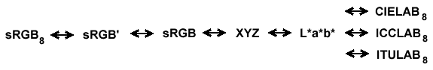

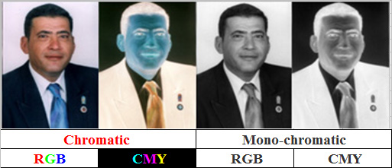

--------------------------------------------------------------------------------------------
http://www.bestjobs.ie/cvs/ahmedyhammad
http://www.bestjobs.ie/
http://www.bestjobs.ie/em-cvs-RS011-1-CV_bank_Kilkenny.htm
Statement of Research Interests
Ahmed Yahya Hammad
Researcher
Agriculture Applications Division
National Authority for Remote Sensing & Space Sciences NARSS
Ministry of State for Scientific Research

I started my employed science, 1987. during this period I obtained Msc. and Ph.D. My Person specification is pomology/Horticulture. My undergraduate education in genetic.
The focus of my doctoral research is on:
1- The 1st was devoted to investigate some remote sensing measurements for distinguishing between mango cultivars concerning their susceptibility to malformation and photosynthesis activity of their leaves at different ages.
2- The second was dealing with investigating the chemical composition nutritional statues, chlorophyll content and endogenous growth regulators levels in relation to mango cultivar and its susceptibility to malformation.
My M. Sc. thesis was focused towards:
1-Recorded of spectral signatures by field radiometer for trees of seven citrus species comprising 13 citrus cultivars to aim at studied effect of Egyptian agricultural environmental factors on spectral reflectance quality as explained satellite image with four electromagnetic wavelength.
2-Recorded of spectral signatures for citrus cultivars using laboratory spectrophotometer as start to record spectral signatures for crops and natural agricultural recourses of Egypt.
-studied dusty in the air effect on the spectral reflectance quality of citrus trees and relation that for estimation area quality to species from TM data.
3-The relation between spectrum quality of crops and characteristics of physiology and histology of it and effect that to identify it within the image.
My general work include remote sensing applications in agriculture. Identification area and estimation of agriculture crops in both aerial photographs and satellite images. Studies on the identification crops and status of stress in trees utilizing spectrum signature using laboratory spectrophotometer and field radiometer also colortron software and thermometer.
My research interests radar applications in agriculture. I am also interested in investigating the Optical properties of leaves. Relation of leaves spectral reflectance with leaf anatomy, pigments and moisture content. Further, I studied in more depth the vegetation index.
My work during the last three years has focused on the development of tools and techniques. Also I cooperated in some agriculture projects using remote sensing technique.
Future my research directions a number of specialized research and application centers are in the process of conducting research on the use of remote sensing in agricultural senses. As for long range plans that presently depend on human factor, by remote sensing techniques if these prove efficient and accurate.

Contact Information and Facsimile
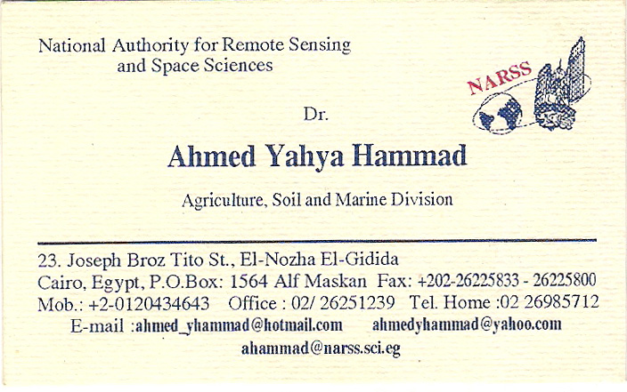
للأتصال
